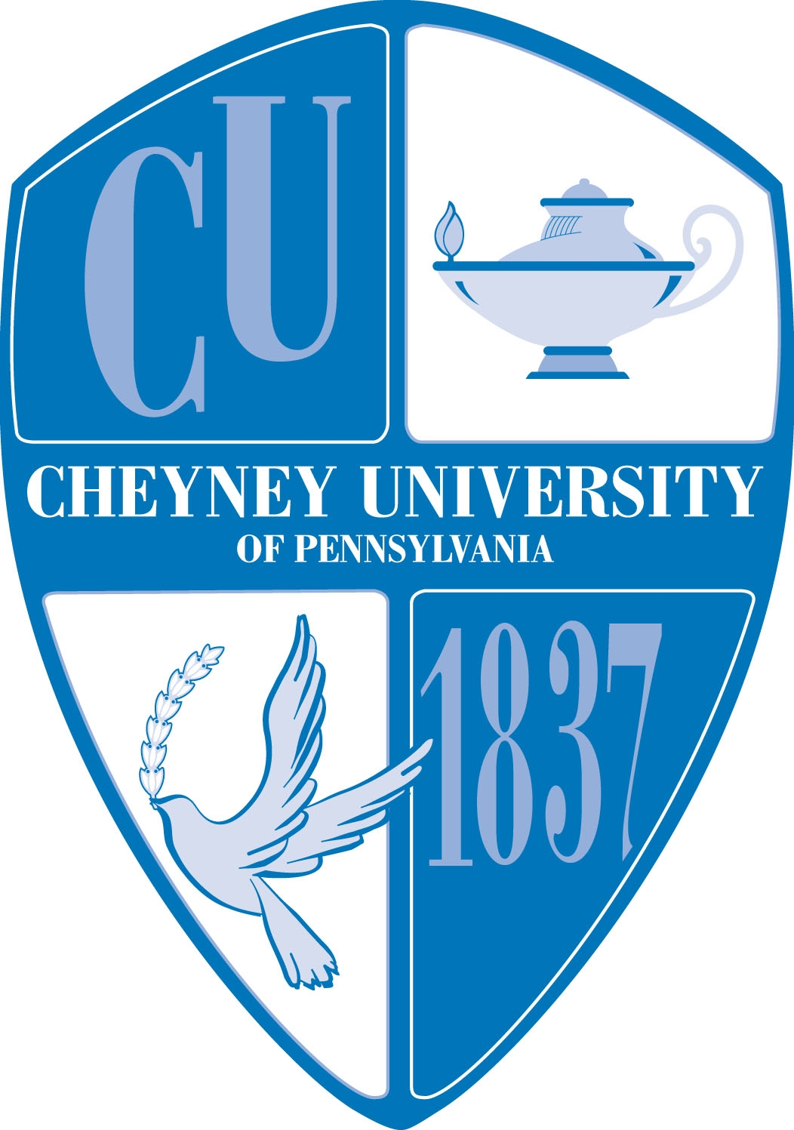
Cheyney University National Alumni Association
William and Marion Schumake Alumni Scholarship
$1,000.00 Award Application – Fall 2018

Date of Application: ____________________

Student Name: ________________________________________________________

Address: ___________________________________________________________________________

___________________________________________________________________________

Phone: ____________________ Email:________________________________________

Date of Birth: _____________Year: ___Freshman ___ Sophomore ___ Junior ___Senior

Major: ______________________________ GPA: ____________________(include transcript)

List extracurricular activities you participate in:
______________________________________________________________________________

______________________________________________________________________________

Essay: Using a separate sheet of paper, attach an essay of no more than 300 words explaining why you think you should receive this award.

Applicant’s Name (please print): _______________________________________________

Applicant's Name (please sign _______________________________________________

Please return completed application by August 31, 2018 to:

Cheyney University National Alumni Association
Marcus Foster Alumni Student Center, Room 218
Cheyney University of PA
1837 University Circle
Cheyney, PA 19319

CHEYNEY UNIVERSITY- WILLIAM AND MARION SCHUMAKE ALUMNI SCHOLARSHIP
$1,000.00 AWARD APPLICATION

PURPOSE OF THE AWARD – To provide seven (7) students with a scholarship award in the amount of $500 for the Fall 2018 semester and $500 for Spring 2019 per student.

APPLICATION PROCESS – Applicants must provide unofficial transcript, bursar statement and all information requested on the application form and return it to the National Alumni Association’s Office prior to the specified date. Application forms will be available in the Alumni Relations Office and on the university’s website and the Alumni Association’s website.

SELECTION PROCESS – Applicants must be currently enrolled at Cheyney University and have a minimum GPA of 2.5. Applications will be reviewed by the Cheyney University Alumni Scholarship Fund Committee. Applications, which are incomplete and/or received after the deadline, will not be considered.

PAYMENT OF AWARD – The William and Marion Schumake Scholarship Award will send the funds to the Cheyney University Alumni Scholarship Fund where they will be placed in a restricted account for the awards. Once the student recipient is identified, the National Alumni Association will advise the Financial Aid Office to apply the $1,000.00 award to the student’s financial aid account.

CHECK LIST:

- Application
- Essay
- Unofficial Transcript
- Bursar Statement
- Release of Information Form

