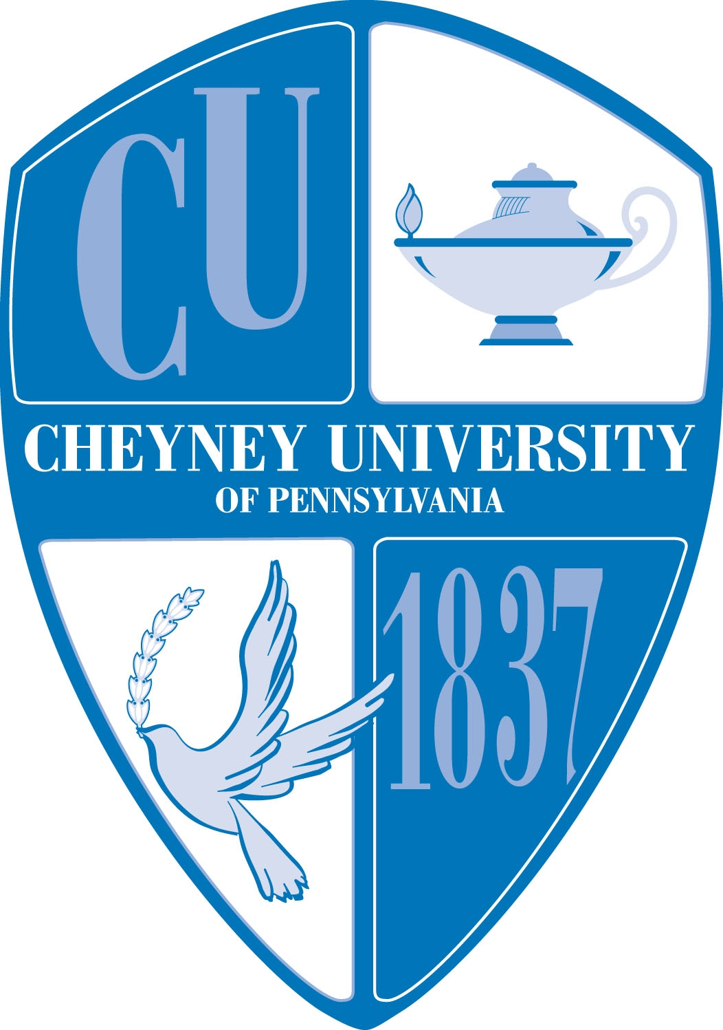

Cheyney University National Alumni Association
Jaime George Alumni Scholarship
$500.00 Award – Fall 2018

Date of Application: ____________________

Student Name: ________________________________________________________

Address: ___________________________________________________________________________

___________________________________________________________________________

Phone: ____________________ Email:________________________________________

Date of Birth: _____________Year: ___Freshman ___ Sophomore ___ Junior ___Senior

Major: ______________________________ GPA: ____________________(include transcript)

List extracurricular activities you participate in:
______________________________________________________________________________

______________________________________________________________________________

Essay: Using a separate sheet of paper, attach an essay of no more than 300 words explaining why you think you should receive this award.

Applicant’s Name (please print): _______________________________________________

Applicant's Name (please sign _______________________________________________

Please return completed application by August 31, 2018 to:

Cheyney University National Alumni Association
Room 218, Marcus Foster Alumni Student Center
Cheyney University of PA
1837 University Circle
Cheyney, PA 19319

CHEYNEY UNIVERSITY- JAIME GEORGE ALUMNI SCHOLARSHIP
$500.00 AWARD APPLICATION

PURPOSE OF THE AWARD – To provide one (1) student with an award in the amount of $500 for Fall 2018.

APPLICATION PROCESS – Applicants must provide all of the information requested on the application form and return it to the National Alumni Association prior to the specified date. Application forms will be available on the university’s website and the Alumni Association’s website.

SELECTION PROCESS – Applicants must be currently enrolled at Cheyney University and have a minimum GPA of 2.5. Applications will be reviewed by the Cheyney University National Alumni Association Scholarship Committee. Applications, which are incomplete and/or received after the deadline, will not be considered.

PAYMENT OF AWARD – The Jaime George Scholarship Award will send the funds to the Cheyney University Alumni Scholarship Fund where they will be placed in a restricted account for the awards. Once the student recipient is identified, the National Alumni Association Scholarship Committee will advise Financial Aid Office to apply the $500.00 award to the student’s financial aid account.

CHECK LIST:

- Application
- Essay
- Unofficial Transcript
- Bursar Statement
- Release of Information Form

