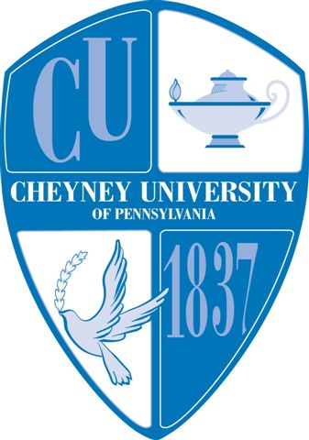
Cheyney University of Pennsylvania
1837 University Circle
Cheyney, PA 19319-0200
Phone: 610-399-200
www.cheyney.edu
May 2, 2014

To Whom It May Concern
This letter is in response to your request that Cheyney University of Pennsylvania purchase and/or provide a certificate of Insurance.

Cheyney University is a part of the Pennsylvania State System of Higher Education, a body corporate and politic constituting a public corporation and government entity. As such, it lacks the statutory authority to purchase insurance and it does not possess insurance documentation per se (i.e., Certificates of Insurance). Instead, it participates in the Commonwealth’s Tort Claims Self-Insurance Program administered by the Bureau of Risk and Insurance Management of the Pennsylvania Department of General Services. The program covers Commonwealth/University owned property, employees, and officials acting within the scope of their employment, and claims arising out of the University’s performance under a contract, subject to the provisions of the Tort claims Act, 42 Pa. C.S.A. §8521, et seq.

The Commonwealth’s exposure to liability (other than Workman’s Compensation) is governed by the dictates of Act1978-152, as amended, commonly known as the Sovereign Immunity Tort Claims Act. Under the Act, sovereign immunity was re-affirmed but waived in eight specific areas of liability. Eligible claims or suites against the Commonwealth, its officials, or its employees, within the waived areas may be settled up to $250,000 per person, $1,000,000 each occurrence.

If I can be of any further assistance in this matter, please do not hesitate to contact me.

Sincerely,

Amber Thompkins
Purchasing Agent
610-399-2129

