Wellness is – The overall fitness of a human being. This is expressed by the level of fitness of the mind, body and soul of the person. It is a holistic approach to lifestyle changes. It involves learning how to balance school, work, home, relationships and play. Wellness is a choice with the personal responsibility to lead a healthy life. It can increase your self-esteem, giving you a sense of freedom and control over your life. Wellness has the potential to increase your happiness and inner peace

MINDFULNESS ACTIVITIES
Mindfulness the action of keeping your thoughts in the present moment. This can be done by focusing on your senses. At this present moment what do you taste, smell, hear, see, feel ?

QUIET IN THE QUAD

WALKING MEDITATION

Meditation and Mindfulness quite simply is the act of focusing on your senses to help keep your thoughts in the present moment. Freely create your own meditation practice.

Begin with breathing inhale and exhale 3x (close your eyes if you like)

Begin walking around the Quad 1x

Here are some prompts to help quiet your mind. Feel free to create your own

MEDITATION PROMPTS
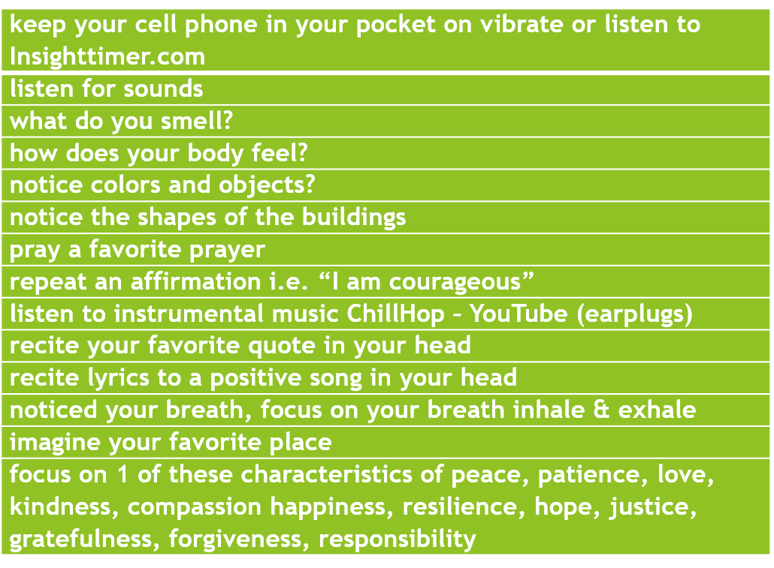

End with breathing inhale and exhale 3x
(close your eyes if you like)

